Guidelines for speakers and session chairs
We are delighted to have you as a speaker and/or session host at the virtual conference DGL 2021 from 27 September – 1 October 2021. In this document we provide you with important information to make sure your session will run smoothly and the conference will turn out a success. Should you have any questions do not hesitate to get back to us:
dgl@fu-confirm.de.

Software solutions
- Our conference platform: SCOOCS
- browser based, no download needed
- Please use Google Chrome (latest version)
- Parallel sessions are realised in integrated video rooms which are based on BigBlueButton (BBB). Plenary sessions are realised in ZOOM rooms.

Technical tests – which date suits you best? Let us know!
To guarantee the overall quality of the congress and to provide room for your questions and remarks well in advance we offer the following technical test opportunities:
- 21 September, 9 am CET
- 22 September 5 pm CET
We strongly recommend participating in one of these test sessions. To participate log into SCOOCS as follows. There will be two test sessions set up for both dates. Simply enter the room.

Register at our conference platform SCOOCS
Login via the following link and simply enter your e-mail address:
https://dgl2021.scoocs.co/checkin

Only use the e-mail address we have been using to communicate with you. Type in your e-mail and click “log in”. Now you will be directed to your profile page which we ask you to fill out as completely as possible. At the bottom you will need to enter a password of your choice.
Now you are registered and SCOOCS starts a short tour through the platform explaining the most important functions. This can be skipped.
Now you are all set and ready to go.

PLEASE NOTE: All registered speakers and chairs will receive a separate email with an invitation to the conference platform SCOOCS.

How to attend
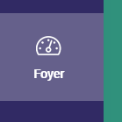
When entering SCOOCS you will always start off at the foyer. (See menu on the left.)
From here you can access all parts of the conference, be it the poster booths, other participants, event information, etc. The foyer also contains the programme and through this access to all conference rooms. Scroll down for a programme overview as well as the detailed version.

Individual sessions can be marked as favourites by clicking on the star behind each session. This makes them appear under “my programme” in the menu on the left.
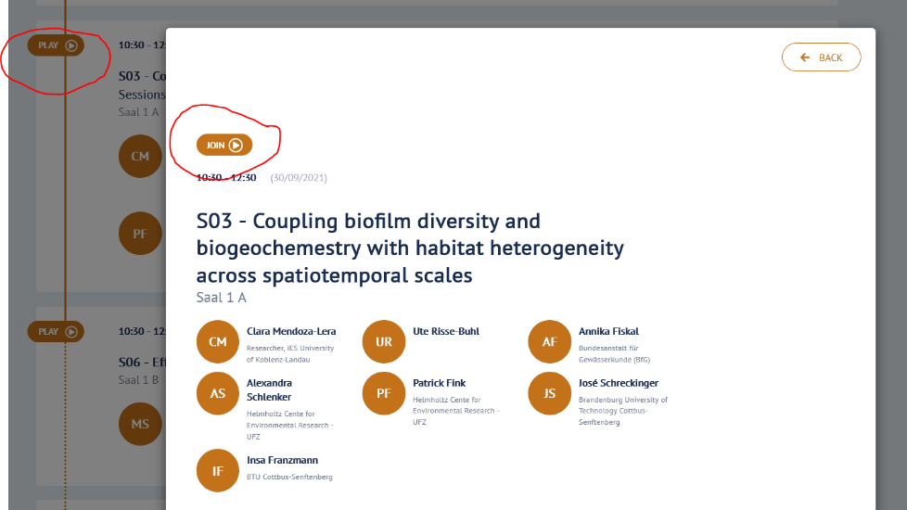
When you want to join a session simply click “play” or “join” on the top left corner of each session to enter the session room.

These integrated rooms are based on BigBlueButton, so those of you familiar with BBB should easily find their way around. Everybody else: Do not worry. It is a simple video room with all of the basic features available.
Inside each room there will be a technical assistant. Feel free to contact them with any technical issue you might have (related to this room).
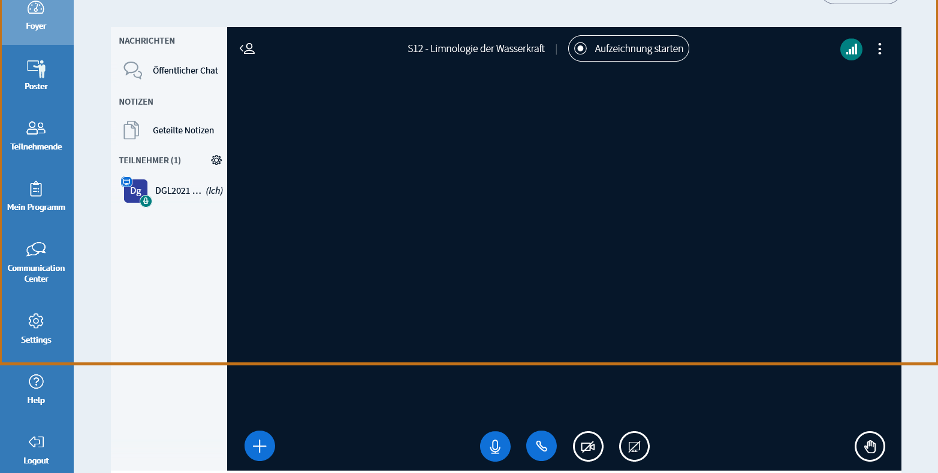

The plenary sessions will be held inside Zoom rooms. Here the procedure will be the same, with the only difference of the Zoom room opening in a separate tab/window. From there on just continue as usual with an invitation to a virtual video room. Here you may choose whether you wish to open Zoom inside your browser or as the downloaded app. The downloaded version tends to be more stable so especially with screensharing you might find it less error-prone that the browser-based version.

Guidelines for session chairs and speakers
As some of you will have both roles during the conference, we took the liberty to send out one single document to everybody. Should you only have one role just skip the rest.
This is followed by general technical tips and information, and some suggestions for setting up your “virtual lectern”.

Session chairs
Session chairs moderate the session by introducing the speakers, guiding the discussion and managing questions and remarks from the audience.

When to be inside the room
Please be in front of your computer and logged into your session room 30 min before the session starts. A technical assistant will welcome you and the speakers. Together you check camera, mic and screensharing and prepare for the session. Once the session officially begins the assistant will let in the audience and you may start. There should be room for questions after each talk, please consider this when planning your session.
How do discussion and feedback work?
The audience can post questions directly into the chat. Should you have enough time and wish to have people interact directly you may also encourage people to ask their questions live. Questions and remarks posted in the chat will be collected and selected by you and asked to your speakers who then answers live. To be on the safe side prepare a handful of questions in advance.

What to do if someone does not finish in time?
Should a speaker speak too long you need to step in and ask them to finish their talk.

What if a talk gets cancelled at short notice? Should a talk get cancelled right before the session, or should a speaker not show up, please use the time for discussion. The schedule should stay intact to give everybody the same rights and possibilities.

Be flexible. Expect speaker changes and no-shows even at a really short notice.

Important: the programme. Please check the programme regularly to see whether any changes were made in your session.

Questions and problems during the session:
A technical assistant will be inside your session room the whole time. They provide technical support to you and the speakers and will hopefully be able to directly solve any technical problems.

Do not hesitate to contact us in advance with any questions you might have:
session@fu-confirm.de
In case of serious technical or organisational issues during the conference we suggest you call us directly:
+49 (0) 341 / 235 22 64
+49 (0) 160 / 4 33 31 39
Session speaker
When to be inside the room: Please be in front of your computer and logged into your session room 30 min before the session starts (not your individual talk!). A technical assistant will welcome you and check camera, mic and screensharing with you. Once the session officially begins the assistant will let the audience enter.

Check the conference programme for your place in the session and the lenght of your talk. Keep in mind that there needs to be room for questions and discussion after your talk. Also make sure you stick to the time schedule.

How do discussion and feedback work?
The audience can post questions directly into the chat, in some sessions there might also be time for live questions from the audience. Your session chair will collect all questions and read them to you, they might also discuss with you themselves.

Important: the programme
Please check the programme regularly to see whether any changes were made in your session.

Should you need to cancel at short notice please do so by e-mail and telephone. During the conference please call us at +49 (0) 341 / 235 22 64

Questions and problems during the session:
A technical assistant will be inside your session room the whole time. They provide technical support and will hopefully be able to directly solve any technical problems.
In case of serious technical or organisational issues during the conference we suggest you call us directly:
+49 (0) 341 / 235 22 64
+49 (0) 160 / 4 33 31 39

Check your equipment
Here you can check whether your computer’s/laptop’s default settings are compatible with SCOOCS. This is independent from the personal technical check that we offer.

Internet speed: A speed of at least 3.2 Mbps in both directions (down and upload) as well as a PING of at least 4ms is recommended. Please test this here.

When participating from a computer inside a secure network at an institution or protected by a firewall ask your IT team to open the following ports:
Conference Server:
Host: 18.197.240.36
UDP ports: 16384-32768
TCP ports: 80, 443 TURN server (relay host):
Host: 18.157.218.165
UDP ports: 443, 3478, 49152-65535
TCP ports: 3478, 443

Questions & problems during the conference:
Our technical support team will be available before and during the whole conference.
Feel free to contact us with any of your questions or requests via e-mail … or by telephone (+49) 0341- 235 22 64.
In case of serious technical or organisational issues during the conference we suggest you call us directly:
+49 (0) 341 / 235 22 64
+49 (0) 160 / 4 33 31 39
Some basic suggestions for setting up your virtual “lectern”
… while we are convinced you have become virtual conference pros over the last 1.5 years, we still noted down some tips and suggestions so that you can literally show yourself in a positive light.

The right place
The right place for moderation and giving a talk
  - is free of disturbances or disruptions like machines that make noise (fax, printer, telephone, fridge, etc.), traffic noise or other outdoor sounds (close the window!), or people bursting in (this also includes our four-legged companions)
  - has a stable LAN connection instead WiFi (the latter not being very reliable)

Camera & lighting
Please set up your camera in a good angle and pay attention to sufficient lighting.
It is quite unfavourable to have the camera angle from above or below. Better set your camera as follows:
  - at exact eye level! If necessary put some books or a small footrest underneath your laptop.
  - at a distance of approx. 60 – 80 cm (~ 25 – 30”) from you
  - you should be visible from approx. the middle of your chest upwards, with some “air” above your head (else you may seem cut off optically)
  - a distance of at least 1.5 m (~ 60”) to any wall or screen behind you
  - the main source of light (daylight, spotlight) must always be behind the camera, lighting your face frontally or diagonally
  - do not use any overhead lighting as your main source of light
  - avoid light sources or shadowing in the background!
  - Your face shines too brightly or the lighting blinds you? ➔ The light might be too direct or too strong:
o Try to point the light at a bright wall in front of you so that it lights you indirectly.

Optimal background
  - Choose a neutral, not too crowded background. Optimal colours: white, beige, light grey
➔ no strongly patterned wallpapers or overfilled shelves
  - Do not sit directly in front of a wall! Leave some space behind you.
  - You may use this space for suitable decoration, e. g. a roll up of the project you are speaking about, or a plant.

The right sound
  - Using a headset is strongly recommended to guarantee optimal sound quality as it highly reduces any acoustic feedback from the loudspeakers
  - Sound is almost more important than the picture: Usually the integrated laptop camera is absolutely sufficient.
  - You only have loudspeakers: Turn them down as far as possible and position them between you and the microphone in your laptop/camera.

Ideal setting: headset with an integrated microphone.
  - The room must not have an echo. If necessary put up a blanket behind your computer and speak into it.

The right clothes
  - Most importantly: You need to feel good.
➔ But: If possible try to avoid checkered or striped shirts, as well as small wild patterns or colours.
  - Do choose colours for your clothing that are different from the wall colour.

