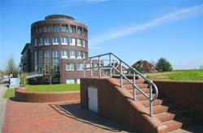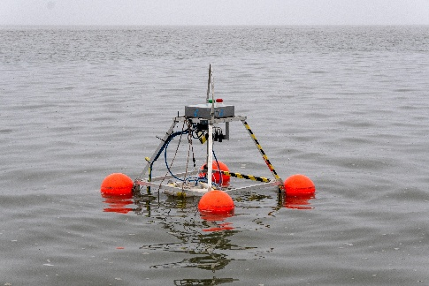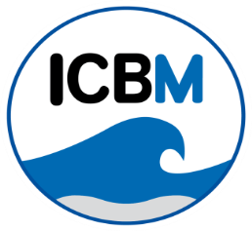

**Bachelor's/Master's thesis or practical course (Kontaktpraktikum) at ICBM!**

**Flexible start date and workplace.**

**Topic: Gas Transfer Velocities and Turbulence**

The ICBM working group "Processes and Sensing of Marine Interfaces" offers the opportunity to undertake a bachelor's or master's thesis in a coastal oceanography project with Matthias Koschorreck from Helmholtz-Zentrum für Umweltforschung (UFZ). There is a chance to complete a contact internship beforehand. A better understanding of the turbulence effects in air-sea gas exchange is necessary to enhance climate models. We propose measuring air-sea gas fluxes alongside oceanic turbulence. We will use two buoys to measure air-sea gas fluxes, an Acoustic Doppler Current Profiler and an Acoustic Doppler Velocimeter attached to the buoy. You can conduct field sampling in Jade Bay or a drinking water reservoir and gain hands-on experience preparing and maintaining ocean technology. This work could produce a quality paper, especially for a master's thesis.

You should have:

* • A passion for fieldwork
* • A strong interest in multidisciplinary research
* • Confidence in communicating in English

We offer:

* • Experience operating the Sniffle (an autonomous drifting buoy for measuring air-sea CO2 fluxes).
* • Data processing using Python and/or Matlab® along with big data management.
* • A pleasant working environment in an interdisciplinary and international team.

Please send your application, questions, or other project interests to Mariana Ribas Ribas ([mariana.ribas.ribas@uol.de)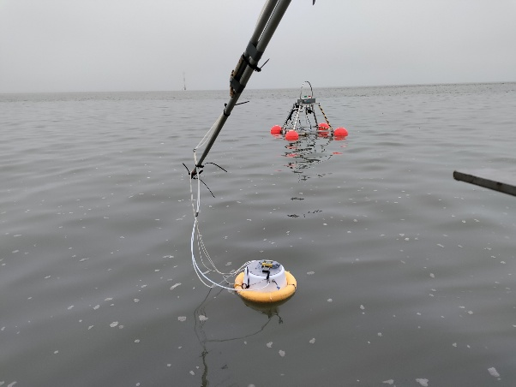](mailto:mariana.ribas.ribas@uol.de)#) 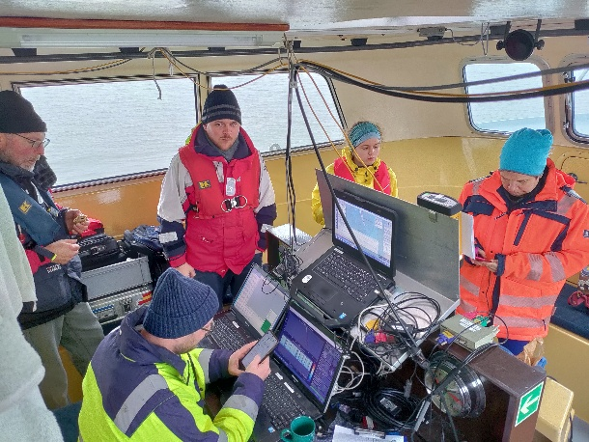

Photos from a cruise with the team in Jade Bay aboard the RV Otzum in November 2024 (credits: Patrick Aurich).